1 Introduction

DarkSpace is a massively multiplayer action strategy game that puts you in command of a massive starship.
- The ship you choose determines your role within the universe…
o Scouts use advanced sensors to find the enemy.
o Engineers can build structures on the surface of planet such as defense bases and barracks to defend the planet from attack.
o Supply ships carry fuel, ammo, and can repair ships close to the battlefield.
o Transports bring troops deep into enemy territory to capture planets, adding their resources and production capacity to your great war machine.
o Frigates are fast and nimble perfect for quick strikes into enemy territory.
o Destroyers serve as the perfect escort ship, protecting the big guns in massive fleet battles.
o Cruisers are the perfect combination of firepower and speed for engaging and destroying the enemy.
o Dreadnoughts act as the ultimate weapons platform, allowing you to launch wings of fighters or bombard a planet into the Stone Age from orbit.
o Support Stations serve as command and repair centers for the fleet. Commanded by the elite Fleet Admirals, these massive structures inspire fear in the enemy.
- Give orders to other players using the command structure.
- Navigate your ship through nebula’s and the rings of Saturn.
- Govern a planet to control its production, diplomatic efforts, budget, and technology.
- Band together with other players and form an empire stretching from Epsilon to Cygnus.
- Trade goods from port to port to make profit.
- Carry out Missions to assist your faction in their galactic efforts both in friendly and enemy territory.
- Scenarios will provide multi-game campaigns, packed with compelling, dynamic game play and a multitude of objectives, ship types and strategies to reach ultimate conquest.
- The Metaverse gives players the ultimate real-time space strategy experience in a massive on-going server complete with multiple star systems and hundreds of planets.

2 Installation
DarkSpace can be installed two different ways, either from a CD-ROM or by a downloaded executable from the Internet.

2.1 Minimum Hardware Requirements
· 300 mhz Intel/AMD Processor
· Windows 95/98/Me/2000 Operating System
· 2nd generation 3d Card (GeForce, Matrox G400, Graphics Blaster)
· 64 MB of RAM, 300 MB of Hard Drive space
· Internet connection, 56k modem or faster
· Direct Input-compatible Mouse

2.2 Software Requirements
· Internet Explorer 4.0+ Web Browser
· Microsoft DirectX 8.0 or higher

2.2.1 Microsoft DirectX
DarkSpace requires DirectX 8.0 or higher; if you do not have DirectX or don’t know if you do, you can download the installer from www.microsoft.com/directx

2.3 CD-ROM
Insert the DarkSpace CD into your computer's CD-ROM drive, and the installer should automatically start. Follow the on-screen instructions.
If the installer does not start, open "My Computer" via your Desktop and browse the CD-ROM drive that holds the DarkSpace CD and run the installation/setup program.
The DarkSpace installation files can also be downloaded from www.darkspace.net in the event that you are unable to install from the CD.
2.4 Internet
DarkSpace can be downloaded from www.darkspace.net in the Clients section of the download page. Click on a client to download, and run the downloaded installer.

3 Players Guide
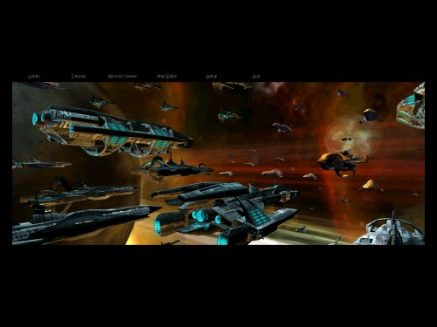
3.1 Starting DarkSpace
The shortcut installed into your “Start Menu” or on your desktop will start the DarkSpace panel. The following options will be available:
Lobby: Sends you directly to the DarkSpace lobby. The Lobby is where you join games and interact with other players in the DarkSpace community. If this is your first time playing, then you will need to create a new account at the login window. Simply click on “New Login”.
Tutorial: This starts the DarkSpace offline tutorial, which will teach you the game basics.
Mission Viewer: While playing DarkSpace, you can save your game to your local hard drive, this program allows you to load these “Mission” files (ending with the .MIS extension) and view them again.
Map Editor: The map editor included with DarkSpace allows you to create your own star systems, and then run them on your own DarkSpace server.
Setup: Use this option to adjust graphic and audio settings.
Quit: Exits the DarkSpace startup program.
3.2 Setup
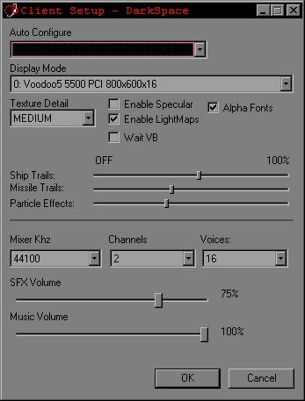
Auto Configure: Used to quick configure DarkSpace graphics and speed options to best match your PC's hardware capabilities.
Display Mode: This setting controls which graphics card DarkSpace will use when playing. The display mode also controls what resolution the game will initialize as well color depth. The minimum resolution is 800x600, but it is recommended that you use 1024x768 since it provides the best game play experience.
Texture Detail: This setting controls how much video and system memory is used by the game. High detail uses the most memory. Low detail uses the least amount.
Enable Specular: Specular highlights make objects appear shiny. Disable this option to avoid the calculations to perform specular highlights.
Enable Lightmaps: Lightmaps make portholes on the ships illuminated. Disable this setting to turn off Lightmaps.
Wait VB: Toggle this option if your experiencing graphics glitches or slow render speeds.
Alpha Fonts: This option controls how text is drawn in game. Turn off this option if text appears corrupted or hard to read.
Ship Trails: This slider controls the length of the ship engine trails. Making the length of the trails smaller will make the game run faster.
Missile Trails: This slider controls the length of missile and fighter exhaust in DarkSpace.
Particle Effects: This slider controls how many particles are used for explosions and other effects in the game.
Mixer KHz: This option controls the mixer rate of the audio system. If your soundcard is older, you may want to lower this number to reduce the amount of CPU time needed to process sounds effects.
Channels: This option controls how many sound channels to use for DarkSpace.
Voices: This option controls the number of sound effects that can play at the same time. Lowering this value will reduce the amount of CPU time needed for sound.
SFX Volume: This controls the sound effects volume.
Music Volume: This controls the volume of the music.

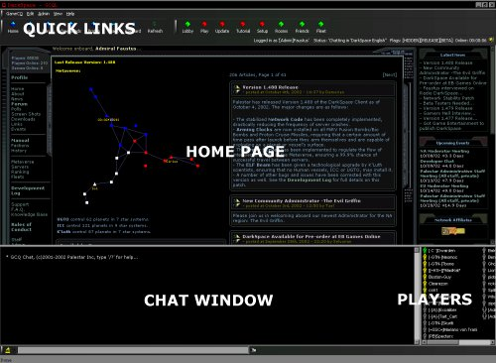
3.3 Lobby
Click on Lobby button from the splash screen to start the lobby.
The Lobby application is where you can chat with other players, view your offline messages, view the forums, check your profile, and more. It’s a great place to hang out before and after a big battle in the Metaverse.
The lower plane of the application is your chat window. The upper plane can be “hung” to view different areas of the lobby. The default view is for displaying the homepage of DarkSpace. Additionally, the button menus can be relocated anywhere on the application to customize the layout.
You will see several diamond buttons at the top…
Lobby: A different lobby for GameCQ can be selected by clicking on this button.
Play: Click on this button to select a game server on which to play DarkSpace. In this view you will see the name of the server, a description, your ping to the server, and the number of players currently playing on that server.
Update: Clicking on this button will download any new updates for DarkSpace.
Home: The homepage for DarkSpace is contained within this view.
News: This view shows you the current news about DarkSpace.
Forum: Click here to access the online Forum of DarkSpace.
Downloads: This is a link to current available downloads from DarkSpace, including wallpaper, clients and maps.
Profile: This view allows you to see your current DarkSpace profile and player statistics.
Rooms: Clicking on this button will display a list of available chat rooms to join. You may also create a new room, which can be password protected to limit access only to those you want in the room. Moderators and Administrators will still have access to all rooms, however.
Friends: Click on this button to display your friends and their locations. The submenu allows you to send a message directly to them, or remove them from your friend list. You can add friends by right clicking on their name in the lower right window, and selecting Add Friend.
Fleet: If you belong to a fleet then clicking on this button will display all the members of your fleet and their location, as well as the ability to message them in the same way as the Friends menu.
Setup: Clicking on this button opens up the DarkSpace Setup menu; this is used to make changes to the graphics and audio settings.
Tutorial: This starts the DarkSpace offline tutorial, which will teach you the game basics.
3.3.1 Login
When the lobby is started you will be asked to login. If this is your first time playing DarkSpace, you should click on the New Login button to create a new account.
Login: Click on this button after you have entered your username and password. If this is your first time running DarkSpace, click on New Login instead to create your account.
New Login: This button will allow you to create a new DarkSpace account.
Cancel: This button will close the login dialog and exit the lobby.
Remember Password: This will save the last entered username and password, automatically filling in those fields for you next time you run DarkSpace.
3.3.1.1 New Login
If this is the first time you are playing DarkSpace, then you will need to create a account for playing. Complete the fields and click on OK to create your DarkSpace account.
User ID: This is your “login name”, also by default your “user name” within the game which you can change.
Password: You should pick a password that is hard to guess, usually a combination of letters and numbers.
Confirm Password: Re-enter your password again to make sure you typed it correctly.
Email: Put your email address in this field.

3.3.2 Joining a Server
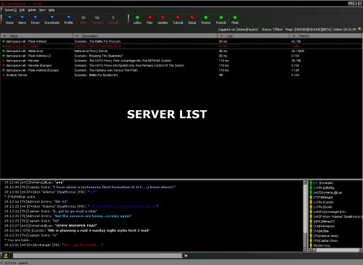
Clicking on the Play button at the top of the lobby will display a list of available servers. Double click on a server to launch the game, or select the server and click Play.
There are four types of DarkSpace servers on which you can play DarkSpace.
Scenario Server: This type of server is scenario based. While playing on the scenario server you will go through a series of scenarios. The next scenario is determined by the outcome of the previous scenario.
Combat Server: This server allows you to just have fun blowing other players up. There are not any statistics tracked on this type of server, so you can’t gain or lose rank.
MetaVerse Server: This server is linked to other MetaVerse servers creating a huge universe. This type of server runs continuously until one faction completely conquers all the servers in the MetaVerse.
Clan Server: This server is restricted to players who belong to a clan or fleet. Players of the same fleet are always on the same team against other fleets.

3.4 Main Screen
Once you have successfully connected to a server, the Main screen will be displayed. Options on this screen are as follows:
Play: Click on the play button to continue onto the team selection screen. If you are a member of a fleet and the server has the clan flag set to "Yes", then you will go directly to the ship selection screen for your fleet’s faction.
Options: Click on this button to view the in-game options screen.
Observe: This button takes you into observe mode so you can watch the action without joining into the game.
LOGOUT: Click on this button to exit DarkSpace and return to the lobby.
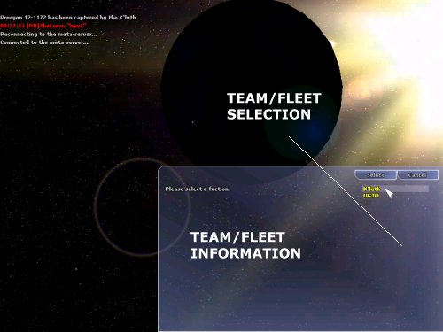
3.5 Team Selection
The team selection screen is where you select whom you want to play with. If the server is balanced, then some teams may not be available for selection; this is done to keep the games balanced and fair for all players.
Simply select a team by clicking on the name, then click on Select button to continue onto the ship selection screen. The Cancel button will take you back to the main screen.
If you have chosen a Clan/MetaVerse server to play on, you may not see the team selection screen, instead you will be taken directly to the ship selection screen.

3.5.1 Factions
In the year 2125, Humanity has split into 2 warring factions for control of known space. This war has been interrupted by first contact with an unknown aggressive alien race called the K’Luth.
When playing DarkSpace, you will choose to play as 1 of the following 3 factions currently available.
UGTO
Established in 2024 after the colonization of mars, The UGTO is the conglomeration of the Old World United Nations and various other socio-political organizations of Earth. The “goal” of the UGTO is to unite humanity under one allegiance of progress and prosperity, although some elements do not see their intentions as being pure and noble. The UGTO spreads across seven systems, has colonies on 12 planetary bodies, and supports a massive collection of outposts and orbiting space stations. It also exerts its power over a number of “independent” planets.
With the advent of interstellar travel humans first sought out their nearest neighbor, the Centauri system, and it was here that the harsh nature of the galaxy revealed itself for the first time. Within the Centauri system there was only one planetary body that was barely environmentally stable enough for humans to visit, Centauri 1-2365. This barren moon was the only planet within the system that was not super-dense and therefore possessing a surface gravity just too high for humans (or human manufactured devices) to endure. Centauri 1-2365 was found to posses trace amounts of metals (about the same quantity as Earth) and so resource extraction development was undertaken. From the Centauri system it was a relatively short hop to the Barnard system where the nature of the galaxy was further confirmed. It turned out that the vast majority of planetary bodies were too hostile for development of any kind, although the Barnard system did have three planetoids that could be developed for resource extraction, and one of these had unheard of amounts of heavy metals present.
It was not until the Wolf system was explored that a planet capable of supporting human life was found. Unfortunately for the first colonists, the contaminants in the atmosphere weren’t discovered until later. Now Ocotat boasts the largest population of any non-Sol system planet ever colonized, thanks to strictly enforced medical policies.
ICC
The ICC was established first as the Free Trade League (est. 2094), and then after a series of violent uprisings and political coups against the UGTO, The Free Trade League splintered from the United Worlds to form the ICC. in 2125. The ICC is currently the strongest opposition against the United Worlds, and is the primary force that hinders the UGTO from gaining majority control of the known universe and the worlds that lie within it. The confederation’s resources, technology, and infrastructure are a fraction of that of the United Worlds, but strong patriotic ideals, resourcefulness and clandestine networks keep the ICC intact, for now.
K'Luth
On August 3, 0645 MST, a UGTO Expeditionary Fleet encountered a force of unknown origin while charting a new quadrant in the outer reaches of the Sirius B system and contact was lost shortly thereafter. Concerned families and opposing organizations demanded immediate answers, which the UGTO Department of Defense responded by stating that a space anomaly, most likely, a black hole was responsible. Since the “Sirius incident”, unidentified spacecraft have been recorded and documented around human worlds and outposts.
The UGTO position on the existence of the K’Luth, or any other extra terrestrial presence for that matter, is officially denied on all fronts. On the other hand, certain parties of the ICC claim to have made “contact” with this mysterious race of aliens. It is rumored that the ICC has acquired technology from the K’Luth, which has put some members of the UGTO council in a state of concern, but the majority of the council believe its just a propaganda ploy inseminated by confederate forces to send the United Worlds into panic. Realizing that the utilization of “new alien technology” could tip the balance of power within the astro-political power structure, the UGTO is conducting a full investigation on the matter.
The K’Luth are rumored to be from somewhere beyond the Sirius system.

3.7 Ship Selection
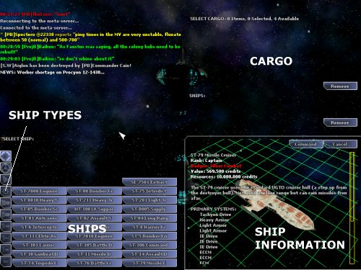
Once your team has been selected, you must now select which ship to commission from the shipyards. There are several factors, which can affect which ships you can commission, most importantly is your current rank. Additionally, badges and medals will make other ship types available to you. Finally, your faction may have limited resources to build certain ships.
Simply select a ship in the list, and then click on the Command button to begin play. Click on Cancel to return to the team selection screen.
You can filter the selection of ships by clicking on the ship icons to the left. Initially all ships are displayed, those that are darker are those you cannot select because of rank or badge requirements, or server rank limitations.
Some ships, although available to your rank, may be disabled because the resources are not available or the rank on the server has been limited.

3.7.1 Ship Classes
Ships come in many configurations, however they all fall into one of the following classes.
Scout: The scout is the primary vessel used for reconnaissance of enemy planets and ships. This ship is usually very lightly armed but some assault scouts are available for quick strikes against the enemy ships. However, the primary role for the ship is to stay outside the range of enemy weapons and provide this intelligence to the larger combat vessels.
Frigate: This vessel is the first true combat vessel above the scout. Although not as fast and nimble as the scout, it can take far more punishment. This type of ship is usually used for patrolling friendly space and attacking incoming transports and scouts.
Destroyer: The destroyer is a step up from the frigate and is good for providing escort for transports and other larger combat vessels.
Cruiser: The cruiser is the main attack ship for engaging targets deep in enemy space. The ship is sturdy and more maneuverable than the larger dreadnaught. The weapon systems of the cruiser can be numerous and usually carries armaments for planetary bombardment.
Dreadnought: The dreadnought is the largest of the available combat vessels. It can penetrate deep into enemy space and has numerous weapons systems, usually including bombs and fighter wings.
Engineering: The engineering ship is used for carrying supplies and equipment necessary to build new structures on newly colonized or captured planets.
Supply: The supply ship carries fuel, armaments, and the equipment necessary to keep a fleet of ships maintained deep in enemy space. This ship is absolutely necessary to until a foothold is established in a new system and the infrastructure has been built to support a fleet of combat vessels.
Transport: The transport is vital because it’s the only ship that can carry a substantial amount of infantry or resources deep into enemy territory. This ship is usually very lightly armed and needs constant escorts otherwise it’s very vulnerable to any enemy combat vessel.
Extractor: Valuable ship class equipped with mining beams. Used for extracting minerals from asteroids, moons, planets and gas giants. Remember to take escort when you fly the extractor, as this ship is easy target for any warship.
Support Station: These massive, slow-moving weapons platforms are used as a unifying point for fleet operations, where vessels can receive a safe haven from small-scale enemy attack as well as repairs and resupply.
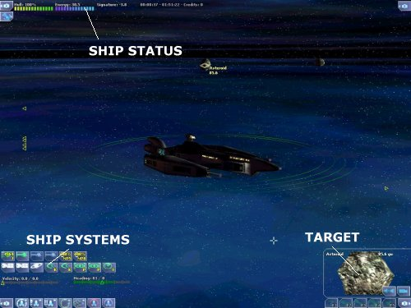
3.8 Tactical Screen
The Tactical screen is the primary interface for controlling your ship.
You can adjust the view of your ship by Holding down the right mouse button and dragging; This will rotate your viewing position around your ship. The TAB key will enumerate through different modes for viewing your ship including Follow and Tactical modes.
The distance between you and your ship can be controlled by using the Mouse Wheel or the X/Z keys.
The Heading of your ship is controlled by a rudder system using the A/S/D keys. The A key turns your ship to the left, the D key turns your ship to the right. The S key stops your ship from turning.
The Velocity of your ship is controlled using the Q/W keys, the Q key reduces your set velocity, the W key increases your ships velocity.
Keep in mind the velocity of your ship can affect your energy and signature. Higher velocities reduce the excess energy available for storage, and increase the signature of your ship.
Your Ship Status is displayed in the upper left of the tactical screen.
- The Hull bar displays the status of your ships hull, and if this reaches 0% then your ship is destroyed.
- The Energy bar displays the amount of energy stored in your ships batteries.
- The Signature bar displays the amount of emissions your ship is generating. The higher your signature, the more visible your ship will be to enemy sensors.
Your Target is displayed in the lower right part of this screen. You can Left Click on a contact icon in the tactical view to set that as your current target.

3.8.1 Contacts
All objects that your ship can currently detect are indicated by colored icon over the center of the object. Arrows along the edge of the screen indicate objects that are not within your view. You simply Left Click on the indicator to target that contact.
Red indicates hostile contacts, Yellow for Neutral contacts, and Green for friendly contacts
Detecting objects simply amounts to how much signature that object is generating, and the more signature there is, the farther away that object can be detected. The signature of a ship can be affected by several factors, most importantly is the velocity of the ship. The faster a ship moves, the more energy is put into its engines and hence it generates a higher signature. Ships with ECM and ECCM devices can also affect ship signature. Nebulae and Stars are considered natural ECM; they always lower the signature of ships within their area of effect.

3.8.2 Manual Targeting
Holding down the Control key will allow you manually target a position in the tactical and navigation displays. This is useful to jump to an empty destination or to fire in the area of ship that you cannot target.

3.8.3 Target Actions
Inside the target window several buttons will be displayed.
Dock: Dock with the current target, this is only valid if you have a ship targeted.
Follow: This button will follow the current target.
Load: This loads the target into your cargo. You must be orbiting the planet to load objects from the surface of the planet.
Orbit: This button will cause your ship to orbit the targeted planet.
Camera: This will change the focus to the targeted object.
Group: This button will join you in a group with the target, or create a new group and invite the target to join.

3.8.4 Ship Systems
All of your ships systems are displayed in the lower left of the screen above the status bar as icons. Left Clicking on a systems icon will activate/use that system, in the case of weapons they are salvoed on your current target. Displayed on the icon is the systems current status. For weapons, ammo will be displayed if the weapon uses ammo.
The brightness of the icon indicates if the device can be used. If the device icon highlights then the device can be used on the current target.
If the system is a weapon, the target must be within the range and firing arc of the weapon. Additionally, the weapon must be charged and in some cases have ammo.
In the lower right of the icon will be displayed the currently assigned group and hotkey.
3.8.5 System Display
If you right-click on a device icon, this will bring up the system display in the lower center of the screen. The system display shows that system status including the current damage to the system.
If this is a weapons system, then the range and arc of the weapon are displayed around your ship above indicated by the red lines.
Also displayed within the system status window are action buttons for that system, depending on the type of system some buttons may or may not be displayed…
Auto Defend: This button is available only for beam weapons, when clicked it will enable the weapon to automatically shoot down incoming missiles and bombs. This is also activated by pressing Ctrl+D.
Auto Off: This button returns the weapon system to manual control.
Repair Now: This button is displayed when the system has been damaged. Clicking on this button will move that system to the top of the repair queue.
Repair Later: This button will move the system to the bottom of the repair queue.
TIP: You can quickly set a weapon for Auto Defense or Auto Attack by just holding down the Shift key and left clicking on the system icon.

3.8.6 Systems Groups
All ships systems can be assigned to the number keys for grouping purposes. Assign a group by first right clicking on the system icon, the either click on the group button or press the “1-9” keys. You can ungroup a system by pressing the “0” key.
Once a system has been grouped, you can simply press the number on your keyboard to use all systems assigned to that group.

3.8.7 Alpha Strike
The Space bar will fire all available weapons at your current target. Special weapons such as bombs and mines will not be fired. Beam weapons set for Auto Defend will also fire if available, making them unavailable until they are recharged.

3.8.8 Point Defense
Beam weapons can be set to defend your ship from incoming projectiles. The easiest way to toggle point defense is to press “Control-B”.
You can set individual beam weapons to point defense by Shift-Clicking on their icon or right clicking on the icon then selecting the “Auto Defend” button.

3.8.9 Cargo
All ships are capable of carrying cargo. If cargo is loaded onto a ship, then the cargo will be displayed directly to the right the system icons. Cargo can be unloaded onto ships and planets. The ability to unload is indicated when the cargo button highlights.
Right clicking on a cargo icon will target that cargo, allowing additional functions. Targeted cargo can be jettisoned into space, by either clicking on the jettison button or using the shortcut Control-E.
Left clicking on a highlighted cargo item will unload that cargo onto the selected target. Cargo can be unloaded onto a specific position on a planet by first selecting a drop target on the planet.

3.8.10 Boarding
Infantry can also be used to board enemy ships. When at very close range, unload the infantry by left clicking on the infantry you want to unload. The infantry will be lost, but will cause major damage to the ships systems or even capture the ship.
Infantry can be transferred to another friendly ship in the same way, provided that ship has enough cargo space.

3.8.11 Sending Messages
Sending messages to your team is done by first pressing the ENTER key, typing your message, and then pressing the Enter key again to send the message. You can abort a message your sending by pressing the ESC key.
Commands can also be entered on the chat line to perform special functions. Online help with the chat commands can by displayed by typing /? In the chat window
3.8.12 Distress Signals
You can send or target distress signals with the following keys:

Control-H - Send attack distress signal. Send this signal if you need help and you are currently losing the battle.
Shift-H - Send a supply distress signal. This lets your team know you need more ammo, fuel, or repairs.
H - Target the last received distress signal.

3.9 Navigation Screen
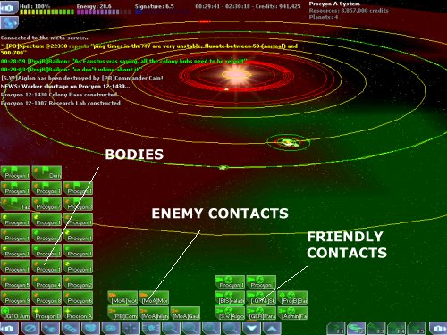
The navigation window gives an overview of the entire system as well as all vessels friendly to your own. You can either click on the navigation button in the lower right panel or use the F2 key to bring this display up.
You can rotate your view by holding down the right mouse button and dragging the mouse. The mouse wheel or the X/Z keys can be used to zoom the display closer or further away from your current target.
You can center the map on your current target by pressing the spacebar.
Near the bottom of the screen are displayed the contact icons. These icons are divided into three groups.
The first group, starting at the left, consists of planets and other major objects your ship/team can detect. If a flag is displayed on the icon, then this planet is an objective planet. Completing all your teams’ objectives will win the scenario.
The second group displays all enemy and neutral ships that are currently detected.
The last group to the right shows all currently detected friendly ships.

3.9.1 Jumping
Jumping to a target is usually done through the navigation window. When you select a target, such as a distant planet, you will see a line drawn between your current position and that target. If the line is solid and white, then a jump is considered safe. If the line is red and blinking, then a jump is considered hazardous and it is generally advised to avoid the jump.
Pressing the “J” key initiates a jump to a destination. Once you either click on the icon or hit the J key, it will take a moment for your ship to align to the destination and slow to a stop before beginning the jump.
3.9.2 Emergency Jumps
In some cases a quick exit from the battle is necessary to avoid being destroyed. Holding down the Shift button and pressing the “J” key will initiate an emergency jump. Your drives will engage immediately and only for few seconds, however this is enough to get you out of the sticky situation.
3.9.3 Jump Fuel
Jumping requires fuel, and a common mistake is to jump too far into enemy space and not have enough to get back.
Watch your fuel at all times, if you do run low you can refuel by orbiting a friendly planet. You can also call for a supply ship with Shift-H; if one is available they will come to your aid. Finally, you can orbit any planet with hydrogen (several types of Gas Giant have Hydrogen). Your ship will scoop the fuel from the upper atmosphere.
3.9.4 Sending Orders
You can set orders for other ships, provided your rank is higher or equal by using the order buttons.
Attack: The target ship should attack the target you select.
Capture: Capture the selected target.
Defend: Defend the select target.
Move: Move to the selected target position.
Cancel: This button cancels any previous order.

3.9.5 Filters
The navigation filters allow you to filter what information is displayed on the navigation screen.

Orbits: This filter toggles the display of orbit paths.
Grid: This filter toggles the display of the color overlay indicating which areas are friendly or hostile.
Planets: Toggle the display of planet icons and their orbits.
Ships: Toggles the display of ships.
Orders: Toggles the display of ship orders.

3.10 Engineering Screen
The engineering window provides an overview of your ships systems and the current repair queue. You display the engineering screen by either clicking on the engineering button in the lower right panel or by pressing the F3 key on the keyboard.
The right portion of the window provides an overview of your ships systems and their current state.
3.10.1 Repair Queue
The left sub-window shows the currently damaged systems onboard the ship and the order in which they are being repaired. When not in orbit around a friendly planet or being repaired by a supply ship only the first listed system is being repaired. The order of the systems can be changed by selecting a system with the left mouse button.
Top – Moves the selected system to the top of the repair queue.
Up - Moves the selected system up one level.
Down – Moves the selected system down one level.
Last – Repairs the system last.
Tip: Right clicking on a system icon, will display the “Repair Now” and “Repair Last” buttons in the system display.
3.10.2 Repairing
Your ship has some capacity to repair it’s own internal systems slowly. However, they can only be repaired one at a time and your hull cannot be repaired unless you have auto-hull repair.
You can get your ship fully repaired by orbiting a friendly planet. If the planet has a depot, then make sure you’re within 100gu of the depot to get repaired even faster.
You can also call for a supply ship by pressing “Shift-H”. If a supply ship is available it can come to your position and repair your ship in space.
Alternatively, Pressing “Control-R” will target the nearest depot or supply ship allowing you to jump to their position.
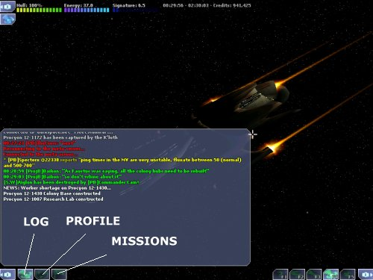
3.11 Communications
The Communications window provides you three different means of receiving information or input from your faction.

3.11.1 Communications Log
The Communications Log gives you a record of a set amount of text so that you can look back over faction communications for messages you may have missed or misunderstood.
3.11.2 Player Profile
The Profile section of the Communications window displays your player information, rank, prestige totals, and badges.
3.11.3 Mission Requests
The Mission window gives you the ability to request a mission for your vessel's class from your faction, if available.

3.12 Planets
Planets are the source of all resources in DarkSpace; resources are vital because they are used to build additional ships. Additionally most scenarios required the team to capture and control most of the planets in a system.
3.12.1 Planet Types
All planets are classified into one of the following types:
Terran - This type of planet is ideal for supporting life; this allows populations to grow quickly.
Arid - Vast expanses of desert, this type of planet is completely devoid of water.

Ocean - Unlike the arid type of planet, this planet has an abundance of water. This type of planet is almost as hospitable as the Terran planet.
Barren - This type of planet has no atmosphere; it’s simply a big rock in space. However these types of planets are usually abundant in mineral resources making them ideal for mining facilities.
Ice - Usually found far out from the heat of a star, this planet is cold however usually more capable of support life than the barren type of planet.
Inferno - The inferno is nothing by a molten rock in space, usually to close to the primary star or a huge gas giant. Nothing can survive on its surface.
Gas - This type of planet consists mainly of gases, usually with a very strong gravity field because of its size. The lack of a surface makes this planet impossible for supporting life.

3.12.2 Governing
Once any planets are under control of a faction, the planets can be managed by clicking on the F5 button; this brings up the planetary management screen.
On the left side of the planetary management screen you will find a row of buttons, these buttons show all of the planets that belong to your faction that can be governed. Clicking on any of the buttons will bring that planet into view. Once the planet is in view it can be rotated and will bring up the management interface.
In the center of the screen at the bottom there are five buttons that control the different management aspects of the planet, these are Units, Research, Build, Structures, and Trade Routes. The function of each of these buttons will be detailed below.
The lower right corner of the planetary management screen shows the current targeted planet with the lock and unlock controls.
Along the right side of the planetary management screen you will find text describing the current status of the planet. The text deals with the following aspects of the planet targeted.

Population
This is the total number of beings currently living on the planet, note that the number represents millions.
Habitat
The maximum population that the planet can support. Building more domes can increase this number.
Workers
The number of workers that the planet has available, workers are needed to run the structures that you build on the planet.
Morale
The current loyalty of the population.
Value
The total credit value of the planet along with its generated income.
Governing Rank
The rank required in order to manage the targeted planet.
Food
The first number represents the food production per round, the second number is the populations' demand for food, and the last number is the surplus or deficit of food per round. It is important to remember that without enough food you cannot increase the population of the planet and thus will not have enough workers to keep a large number of structures functioning. Remember also that the population can starve to death if they don't have enough food.
Power
Reactors that you build on the planet generate power. If there is not enough power some of your structures will go offline and cease functioning until power is restored.
Research
The speed that a planet can develop new structures and technology is determined by this structure. The higher the number, the better. All planets get a base research value of 25 with a colony hub; every research lab built increases this number.
Resources
This is the list of materials that the planet has in reserve for building, research, and trade. The resources are Cyrometals, Darkmatter, Food, Heavy Metals, Hydrogen, Hypermatter, Metals, Oxygen, and Urdanium.
Special Events
Special circumstances on the planet such as the discovery of a vein of Cyrometals or a workers strike.

3.12.2.1 Trade Routes
Trade routes can be used to transport goods from planets. You can set trade routes between multiple planets using the F5 Governing screen.
Under the “Trade route” button, you can import and export goods between these planets as per your wishes. You can click an icon in the Export/import list to start importing/exporting those goods.
However, keep in mind that a planet needs a starport to be able to import/export goods. Once a planet gets a starport a transport ship will move into orbit, and this transport will take care of the importing and exporting needs of the planet.
3.12.2.2 Units
The Units button shows the current status of the troops deployed and training on the planet. Troops that are active are displayed in green, while those in training are displayed in red. Green troops also display their experience. Troops can only be trained on a planet that has barracks built.
3.12.2.3 Research
The Research button brings up the icons for all the structures and technology that can be researched by the planet. The technology that has been researched is displayed in green, the technology that can be researched is shown filled in, while technology that is currently being researched has a flashing border. All technology shows the time that the research will take at the current development level of the planet. Technology that is being researched shows the time remaining before the research is complete. Moving the mouse cursor over any of the research icons will show what research they need and lead to.
3.12.2.4 Build
The Build icon opens up the build interface for the planet. Simply click on the desired diamond on the surface of the planet and icons showing all the structures that the planet can produce will pop up over the planets display in the lower right corner of the management screen interface. Click on the structure that you wish to build and the planet will begin to build it.
3.12.3 Structures
Once a planets surface is controlled, infrastructure can be built to improve the planets resource production. Resources ultimately are sent back to the home system where they are used to manufacture additional ships.
Structures can be built by using construction drones from an engineering ship or by the planets population.
An engineering ship can build by orbiting the planet, selecting a build location on the planet, then clicking on a structure button above the target window.
If the planet has a colony hub and has researched the structure, the structure can be built on the planet by selecting a build location from the Planets Screen (F5) and clicking on a structure button about the target window.
All structures have a Build Cost, which must be located on the planet before the structure can be built. A transport or extractor may be used to bring the needed resources to a planet.
Most structures require Workers. These workers come directly from the planets population. Population requires Habitat space to grow; some types of planets such as Terran and Ocean start with natural habitat. Barren planets require Domes to be built, which increase the habitat space available.
All structures require Power to operate. You can generate additional power by building generators (Solar and Fusion) on the planet's surface.
3.12.4 Planetary Invasions
Controlling the planets surface is necessary to build structures on a planet and extract the resources. Gaining control of the surface is accomplished by landing ground troops onto the planets surface; enemy troops already on the surface will attack any invaders. Ultimately, the last man standing is who controls the planet.
3.12.5 Bombardment
Before troops are dropped onto a planet, it can be softened from orbit. However, orbital bombardment can destroy infrastructure and kill off millions of the planets population. Almost always, if a planet can be captured by troops alone, the infrastructure and population of the planet are left unhurt.
Planets can be bombed if a ship has the armaments, simply target the planet and press the “B” key to release the deadly payload onto the surface.

3.12.6 Infantry
Controlling the planets surface requires that only your forces be on the planets surface. When enemy infantry is dropped onto the surface from orbit, it will seek and destroy any other enemy infantry and units. Once all enemy units have been eliminated, the victor controls the planet.
Some ships come with Infantry units already onboard, specifically the transport. However, most infantry must be trained by building a barracks on a controlled planet.
Units can gain experience for each battle that they survive and from training on planets. This experience will increase the units combat abilities.
Green – Fresh troops, no or very little combat experience
Veteran – Some combat experience
Hardened – Good combat experience
Elite – Excellent combat experience, all attacks are double
3.12.7 Revolts
Although a planet may be controlled by a military presence, sometimes the population of the planet will revolt, making the planet neutral to the war.

3.13 Nebulae
Gas clouds in space, which are the remains of a star that has lost since died. Nebulas and gas clouds provide a natural source of ECM, making it almost impossible for ships sensors to function.
TIP: Moving your ship into a nebula usually makes it possible to escape enemy vessels.
3.14 Stars
Stars provide another source of natural ECM like Nebulas, however get to close and no ships hull can withstand the radiation and heat.
3.15 Hazards
All kinds of other hazards exist in space, from a hidden black hole to an unknown form of life. Fly with caution should you ever discover one.

4 Credits
Engine/Game/Server Programming  Richard "Faustus" Lyle  Game Design  Shawn "Nimby" Foreman  Richard "Faustus" Lyle  Sean "Taelron" O'Connor  David "Dwarden" Foltýn  Art  Joseph Santori  Mike Washburn  Aaron "Otsunashi" Keesee  Elizabeth "Coleen" Smith  Josh "Gideon" Smith  Music/Sound  Paul Baker  Nenad Vugrinec  Lobby Programming / Tutorials  Christian "Chromix" Morgenstern  Web Programming  Oliver "StarDust" Poetzelberger  Story  Shawn "Nimby" Foreman  Josh "Gideon" Smith | Community Administration  Shawn "Selvarian" Stamps  Christian "Sunshine" Weyand  Daniel "Samweis" Klug  Sean "Taelron" O'Connor  Leigh "Dr Evil" Reimers  Rodger "The Griffin" Griffin  Markus "Bumblebee" Hummel  Special Thanks  Tracy Demaret  Kevin Sturdivant  Thomas Hertzler  Mark Hall  Miles "Demorian" Moffit  Jeffrey Heyman  Jason Templeman  Todd Templeman  Dennis Gyor  David Klein  Al Corey  Troy Lowe  Thanks to all the moderators, too numerous to mention, who make the DarkSpace community so great.

5 Keyboard
GLOBAL  F1 Help  F2 Navigation  F3 Engineering  F4 Chat Log / Profile  F5 Planetary management  Alt-F4 Exit  Alt-R Toggle mission recorder  Control-D Self Destruct  H Target Last Distress  Control-H Send Distress Signal  Shift-H Send Supply Distress Signal  TACTICAL  A/Left Turn Left  S Stop Turn  D/Right Turn Right  Q/Down Decrease velocity  W/Up Increase Velocity  X/Z Zoom Camera  ENTER Begin chat message / Send chat message  SPACE Fire all weapons  1-9 Use Group  E Next enemy target  Shift-E Closest enemy target  R Next friendly target  Shift-R Closest friendly target  Control-R Closest Supply/Depot  Control-J Closest friendly jump gate  [ Decrease contact range  ] Increase contact range  / Toggle Shield/Armor/Turn displays  F Follow Target  G Dock Target  O Orbit Target  L Load cargo  U Unload cargo  Control-T Trade | NAVIGATION  X/Z Zoom  Shift-Z Min Zoom  Shift-X Max Zoom  SPACE Center on target  J Initiate jump  Shift-G Toggle control zones  Shift-O Toggle orbit paths  Shift-P Toggle planets  Shift-S Toggle ships  Shift-K Toggle orders  A Order attack  C Order capture  D Order defend  N Order cancel  DEVICE SPECIFIC  B Bombs  Shift-B Explode bombs  K ECM  P ECCM  K Cloak  J Jump  Shift-J Emergency Jump  T Tractor beam  Shift-T Reverse tractor beam  Y Reload  Shift-Y Reload self  N Fighters  Shift-N Recall fighters  MISC  Alt-P Profile Information  Alt-T Capture screen shot

